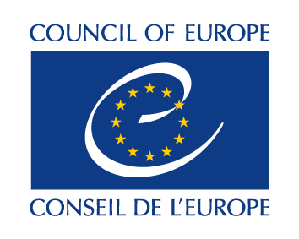
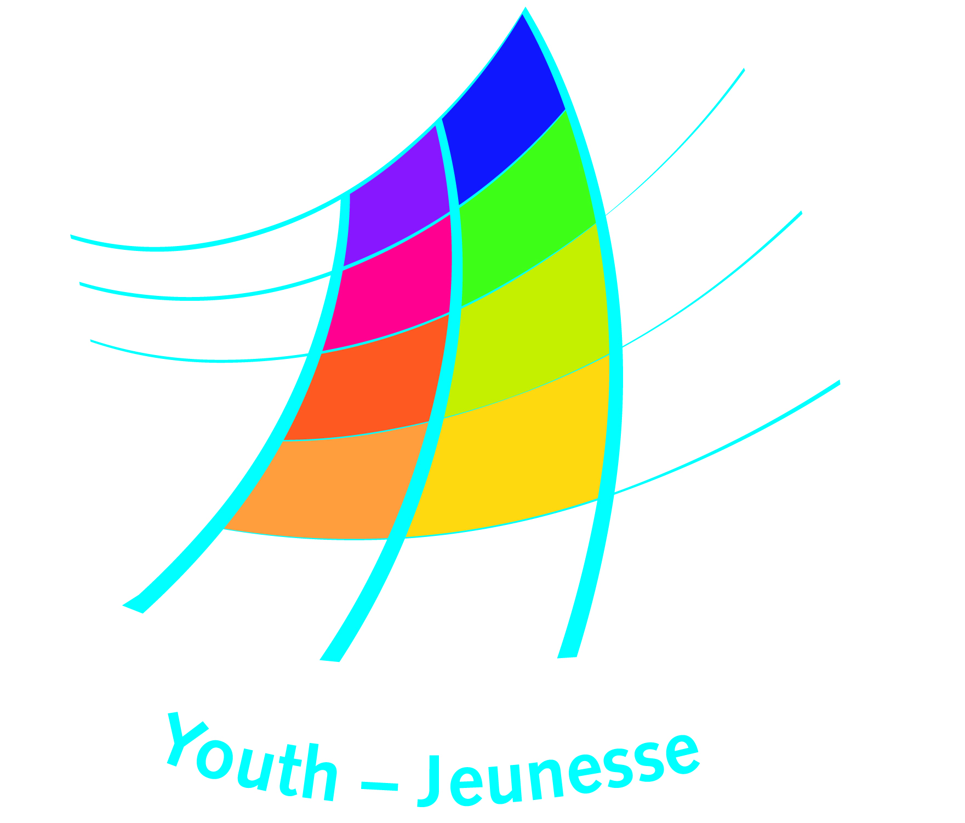

YD-TP/ET N°/year Date of posting of the call

Trainers’ Pool

Call for Expressions of Interest to the Trainers’ Pool
by an External Partner

1. The Organiser | Name
 | Address
 | Telephone
 | Web page
Contact person | Name
 | Function
 | Telephone
 | Email:

2. The activity
Title:
Details:
Please describe the general purpose and context of the activity, including the objectives and target group)

3. Nature of the Task - please describe, as concretely as possible, what the trainers are expected to do or needed for (e.g. preparing a training course, providing an experts input, etc.)

4. Competences required – please list the most important competences that trainers need to have, in relation to, for example: the themes or issues addressed in the activity; the target group; the nature of the task; the level of the training

5. Specific Conditions
Venue and dates of the activity

Venue and dates of preparatory meetings (if known)
Working languages
Honoraria proposed (if available)
Any other particular conditions

6. How to apply
Deadline for reception of expressions of interest:
Contact (email address to which trainers may send their expressions of interest):
Form (how the trainers should express their interest, any specific information or documents to append, etc.)

7. Other
Any other additional useful information

Please send this request via email to Youth.trainers@coe.int and to Katalin.ormos@coe.int

To be completed by the secretariat of the Youth Department
Additional information may be provided in separate documents
For example: 1. Ability to introduce, explain and facilitate individual and group learning in the areas of: youth policy development; non-formal education; youth participation; leadership and communication - Familiar with the meaning and practice of these concepts in the Council of Europe and in youth work. - Ability to introduce the relation between youth work, non-formal learning, human rights and democracy. - Experience in preparing and running intercultural training activities based on non-formal learning approaches. - Ability to contribute to and work in an intercultural team of trainers. - Fluency in Russian and in English. - …

